How Do I Add an Assessment to the E-portfolio if I’m not the Nominated Supervisor?

To enter COTs and CBDs without using someone else’s password:
- Go to: https://eportfolio.rcgp.org.uk/forms Alternatively, if you can’t remember this page, go to the e-portfolio home page and you’ll find a link there

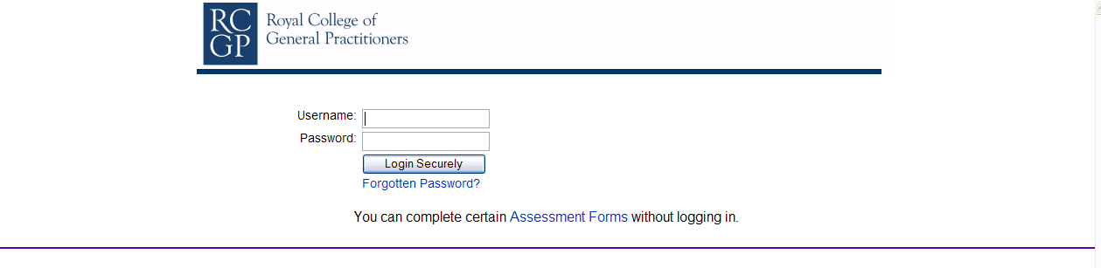
- Enter your name, designation and GMC or NMC number (where applicable, for verification purposes).
- Enter the Ticket code press continue to form. The ticket code determines the type of assessment.
To get a ticket code: the trainee logs into their e-portfolio and clicks on the appropriate assessment (eg CBD etc) and then clicks “Request an assessor completes a form” which then generates a ticket code. I know this sounds complicated, but it’s easier to do than the written instructions would indicate.
HOWEVER, there is an alternative easier method: forget generating the ticket code: just go straight to the above link and instead of inputting the ticket code, enter the GP trainee’s details.
- Confirm your details are correct on the next page and then continue to the form.
- There will be random checking of submitted forms to verify that they were submitted by the stated assessor.
- Further guidance is available at /Documents/CBD.asp.
GMC numbers (including your own) can be found by clicking this link:
http://www.gmc-uk.org/register/search/index.asp#

